**BuzzyDoc Reward Site**

**URL :** <http://buzzydoc.sourcefuse.com/>

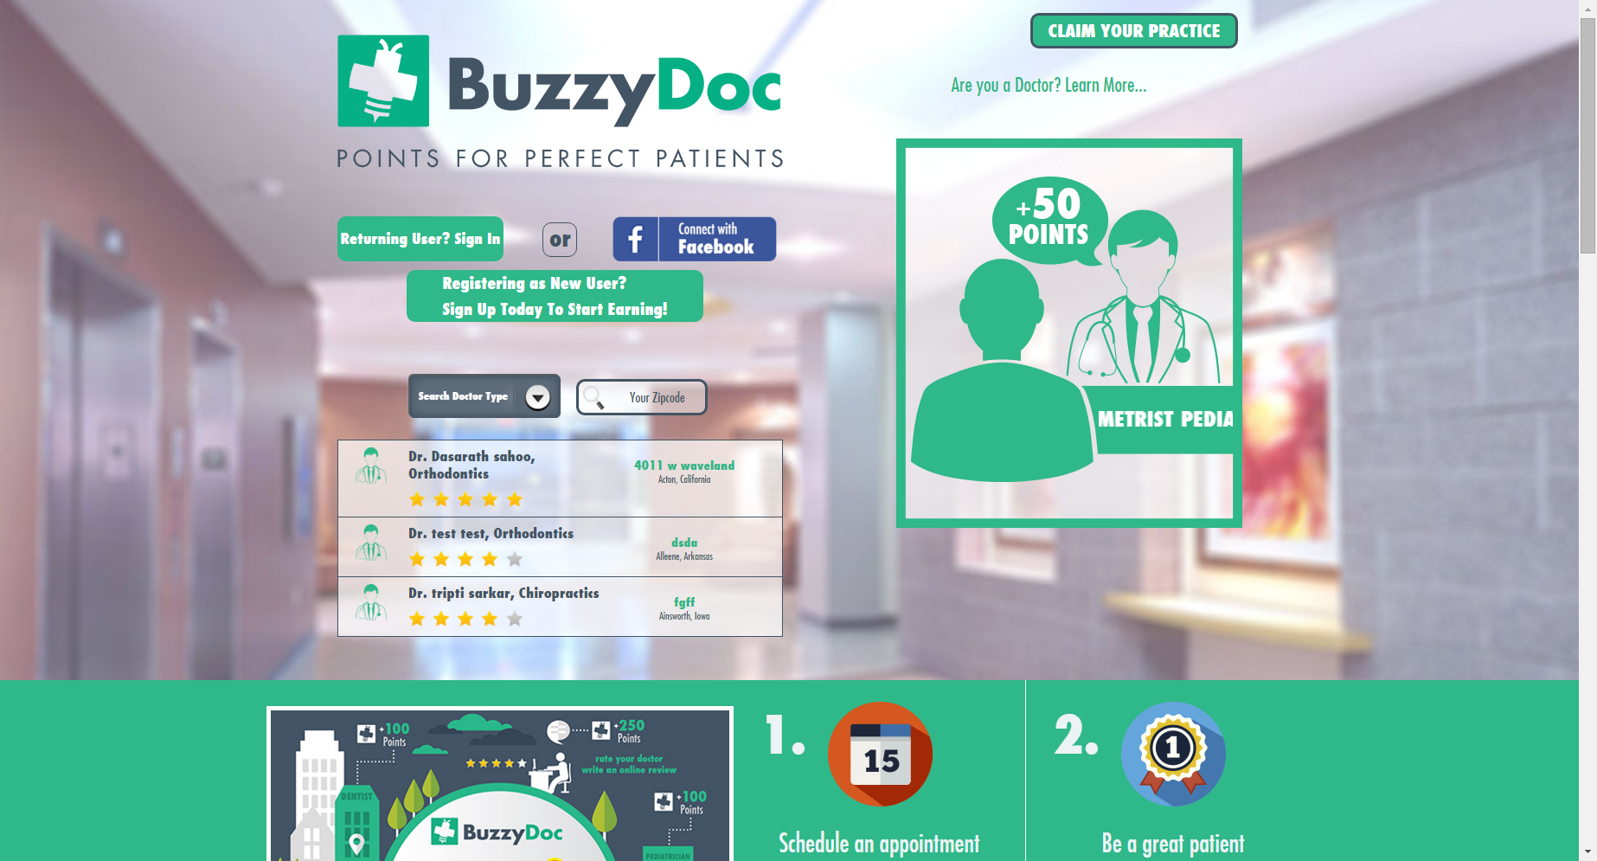

User can manually Signup or directly from Facebook.

1. **Signup**

To Sign up Practice Name and type needs to be defined as Patient will be registered for that Practice.

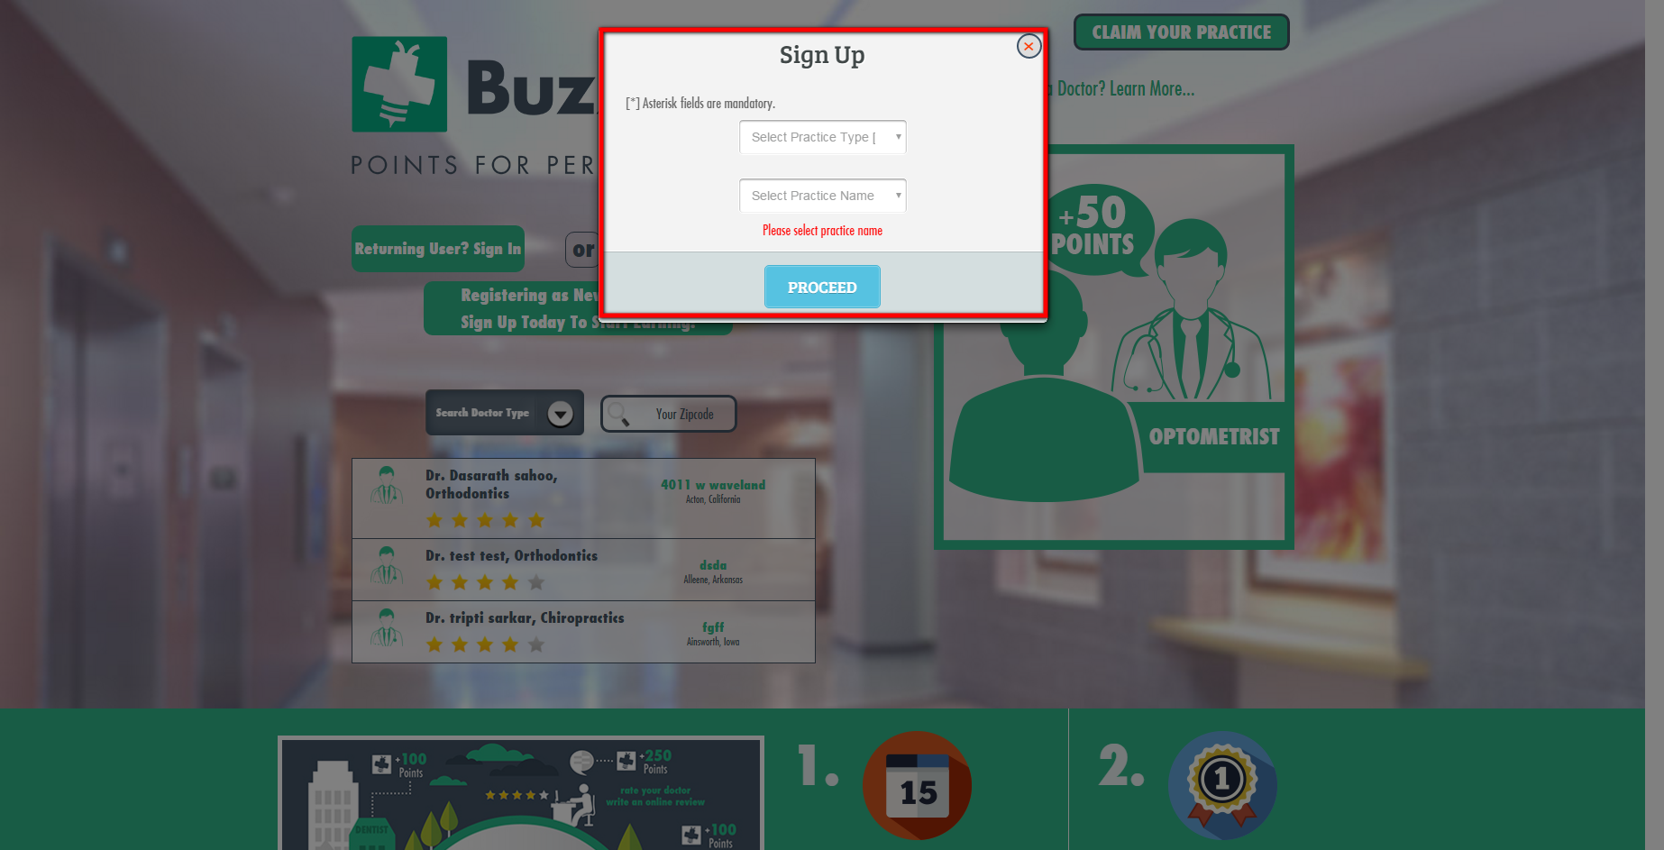

On clicking Proceed button next Sign up form shows up

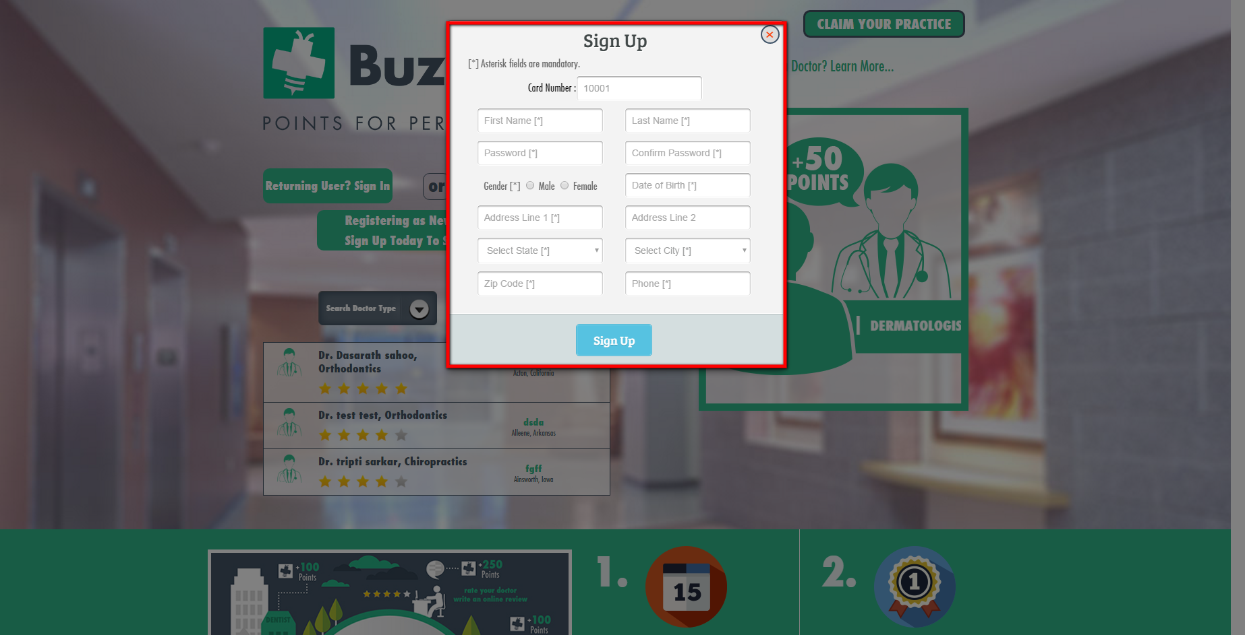

All the fields are mandatory to be filled while signing up.

**Date of Birth Field Logic**

* If the patient’s age is less than 15 years then extra field asking for Parents Email Address will be shown so to ensure rightful activity.
* But if the patient’s age is in between 15 to 18 years then radio button asking whether given Email is of Parent’s or of Patient himself.
* If age of patient is more than 18 years then Email field will be showing considering it as patient’s Email.

**2.** **Sign In**

Once user gets logged in by clicking Sign In button from Home page and entering Credentials he will be redirected to BuzzyDoc Reward Page from where User can perform different activities like Redeeming, Earn , Check In’s etc.

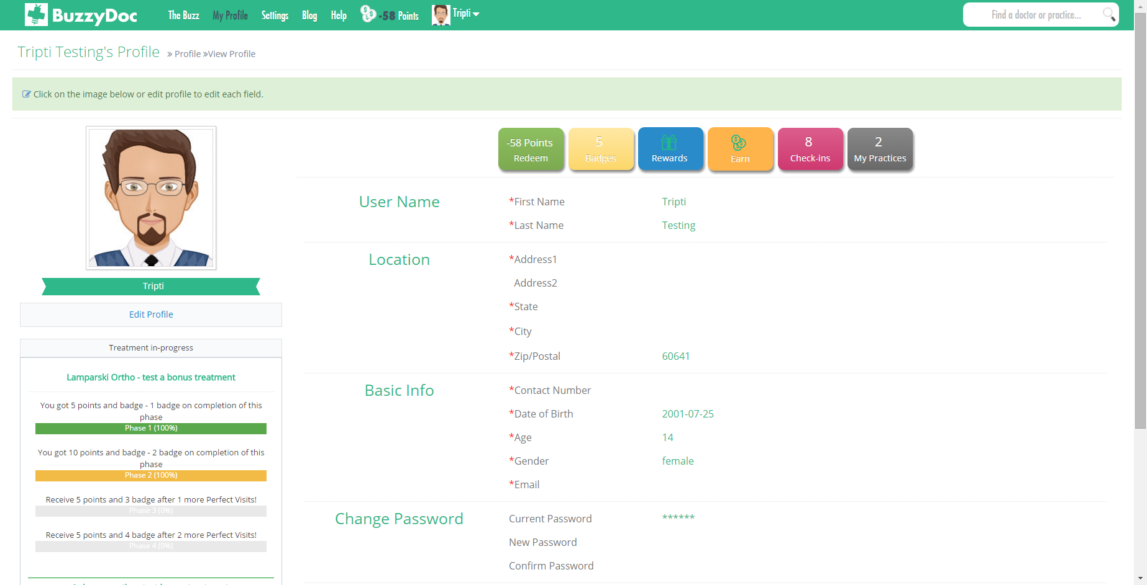

**3. My Profile**

It shows the basic details of the patient. It allows to view Edit details, View Treatment in Progress, Badges, Rewards, Check-In’s, Practices.

* **Redeem**

User can Redeem points by clicking Redeem Points button under Redeem section. User can redeem points either from Amazon or from Tango,even if user has less points he/she can redeem points and can pay remaining balance to the staff member while collecting.

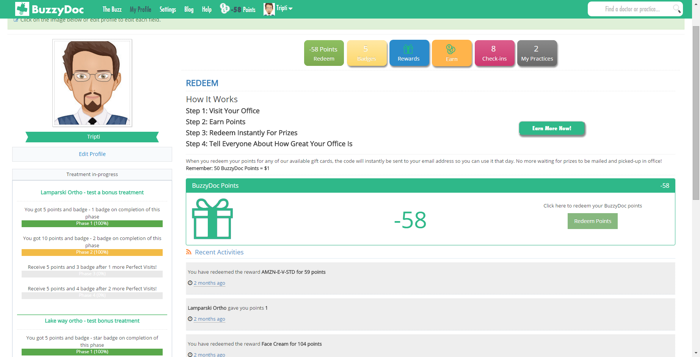

Recent Activity shows all the activity related to the patient which includes points redemption points rewards etc.

* **Badges**

It shows all the milestones the patent has achieved and accordingly all the Badges corresponding to milestones are shown.

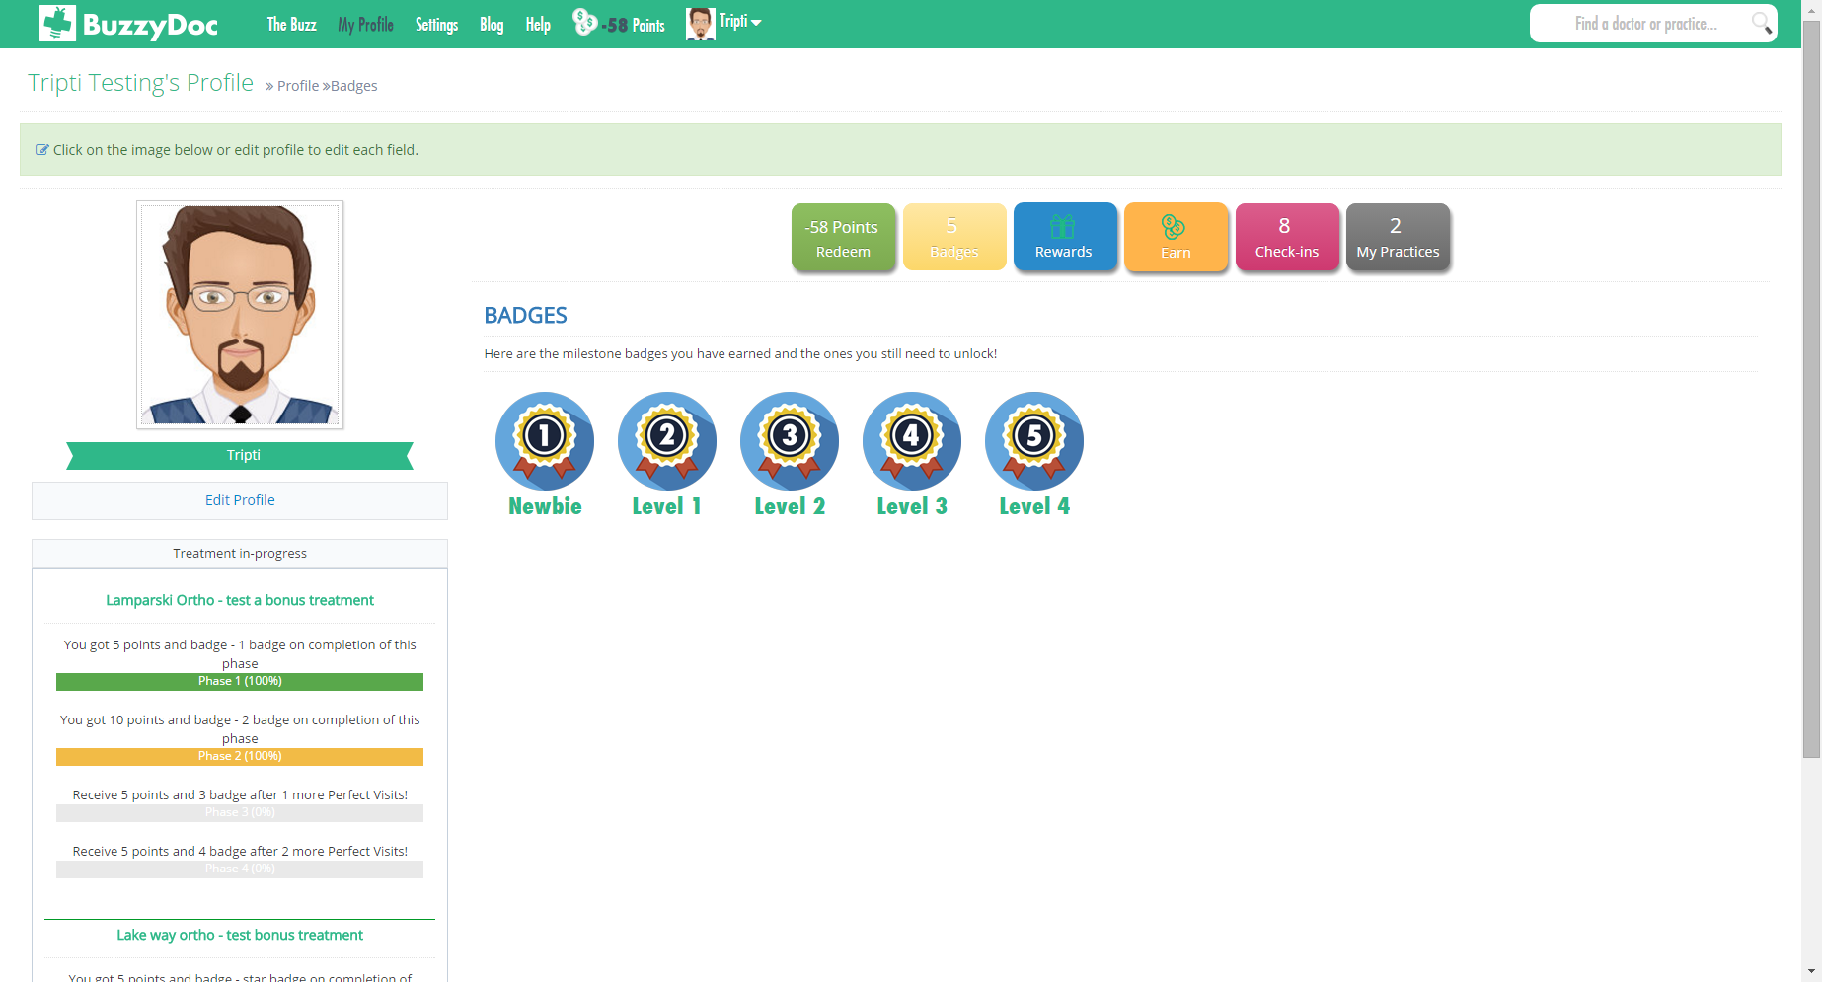

* **Rewards**

From here patient can view Products and Services which can be redeemed

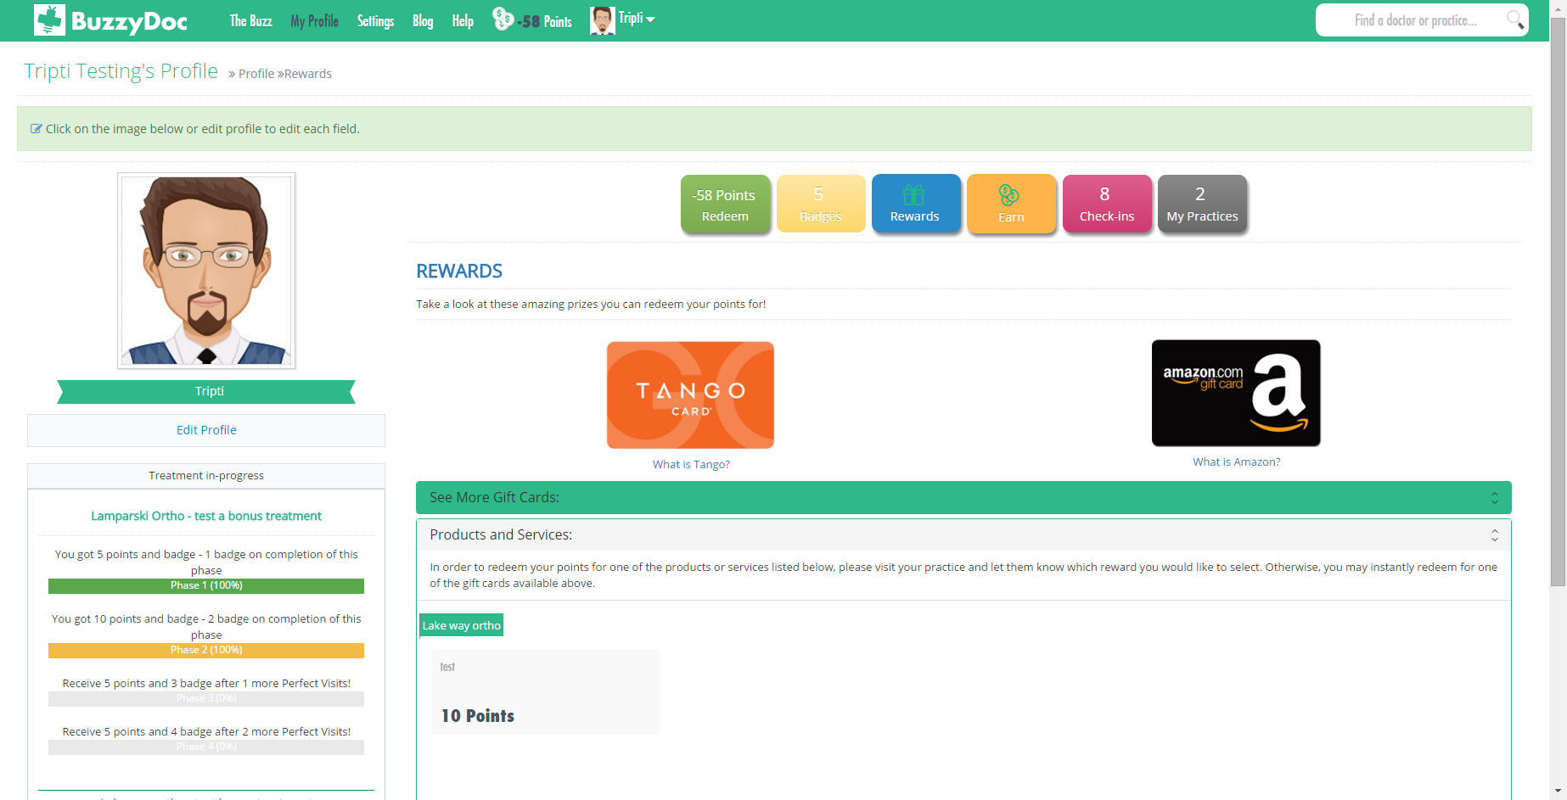

* **Earn**

Earn is a section from where user can Earn points by referring friends and when they become patients User gets points. User can also Earn points by liking practice FB page.

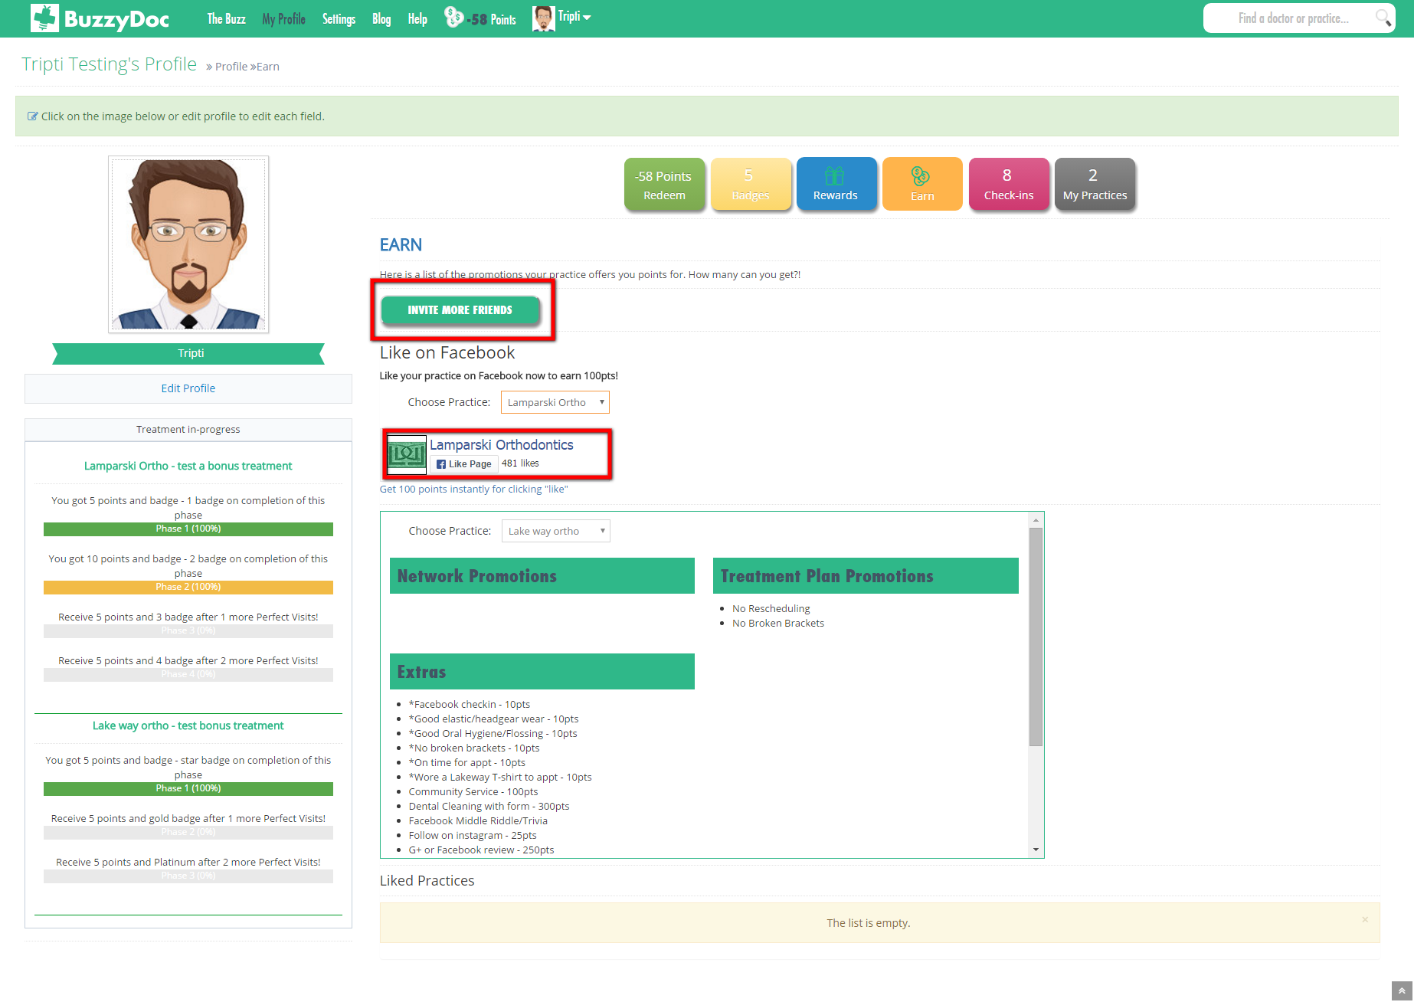

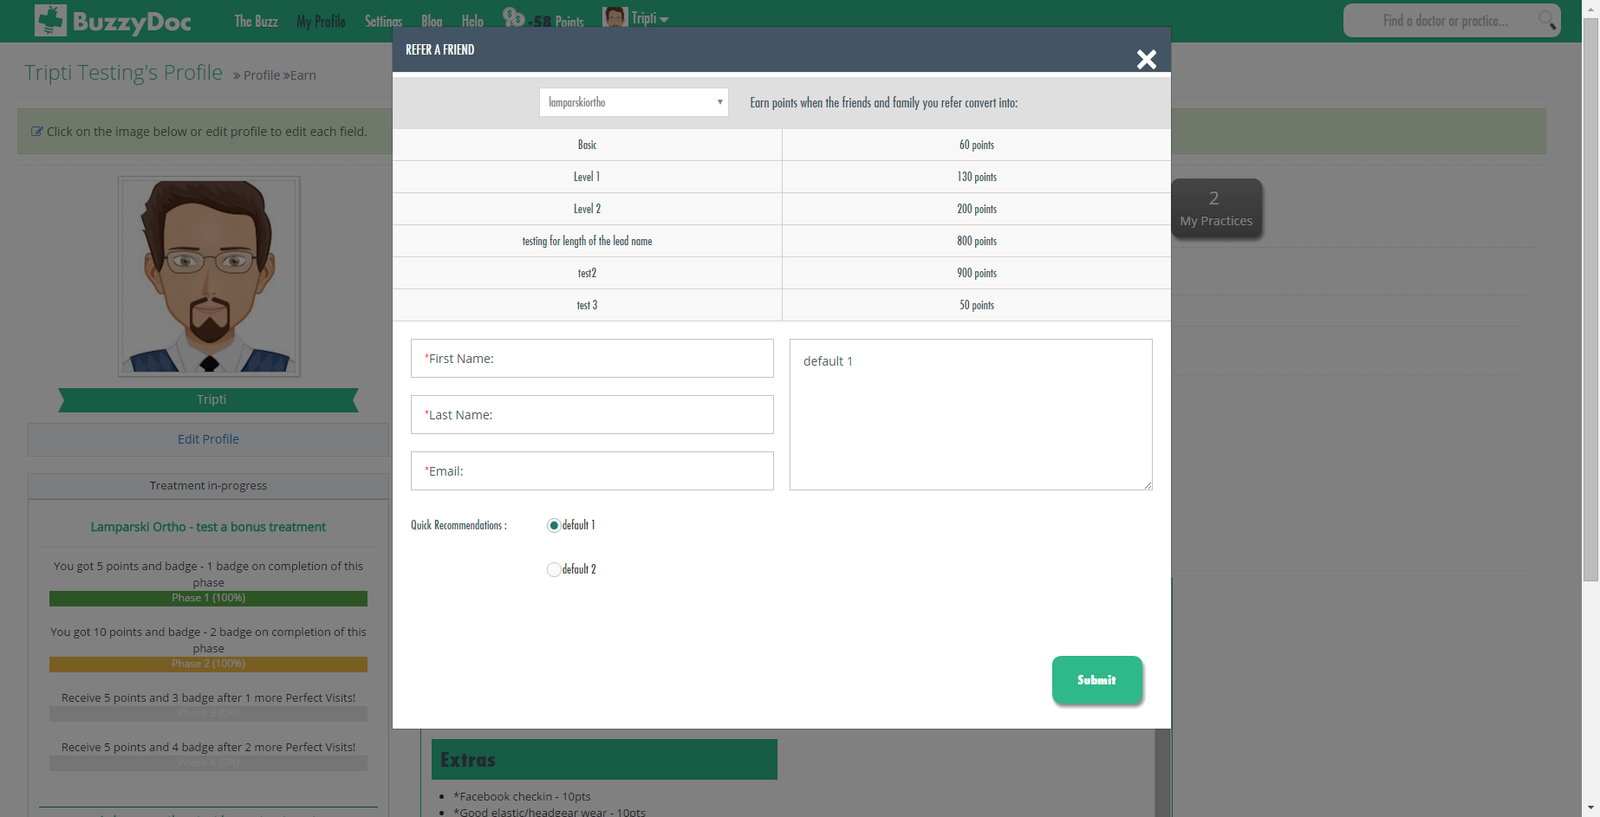

Once user refers a friend an Email s sent out to the referred person asking to register himself/herself with the clinic.

On referring a friend, when referred person registers himself/herself to practice then User is rewarded some points.

* **Check In’s**

First points of the day given to the patients are stored and displayed under this section. It only stores 1st Reward of the day, even patient is rewarded with other points also on same day only 1st Transaction will be shown.

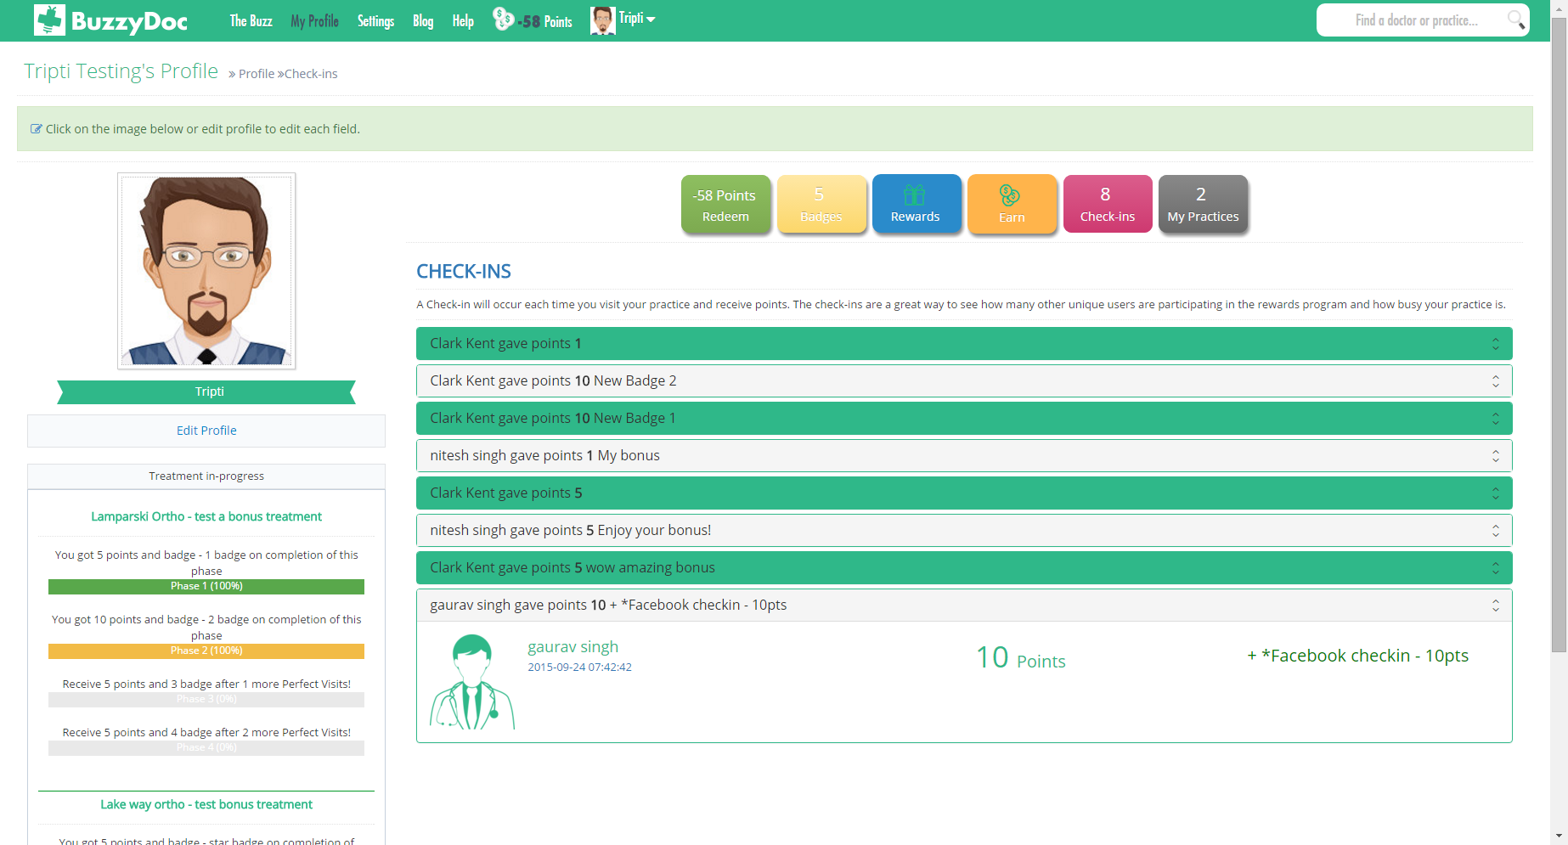

* **My Practice**

It shows all the Practices to which Patient is associated with and allows to shows all the Doctor’s profile user has saved.

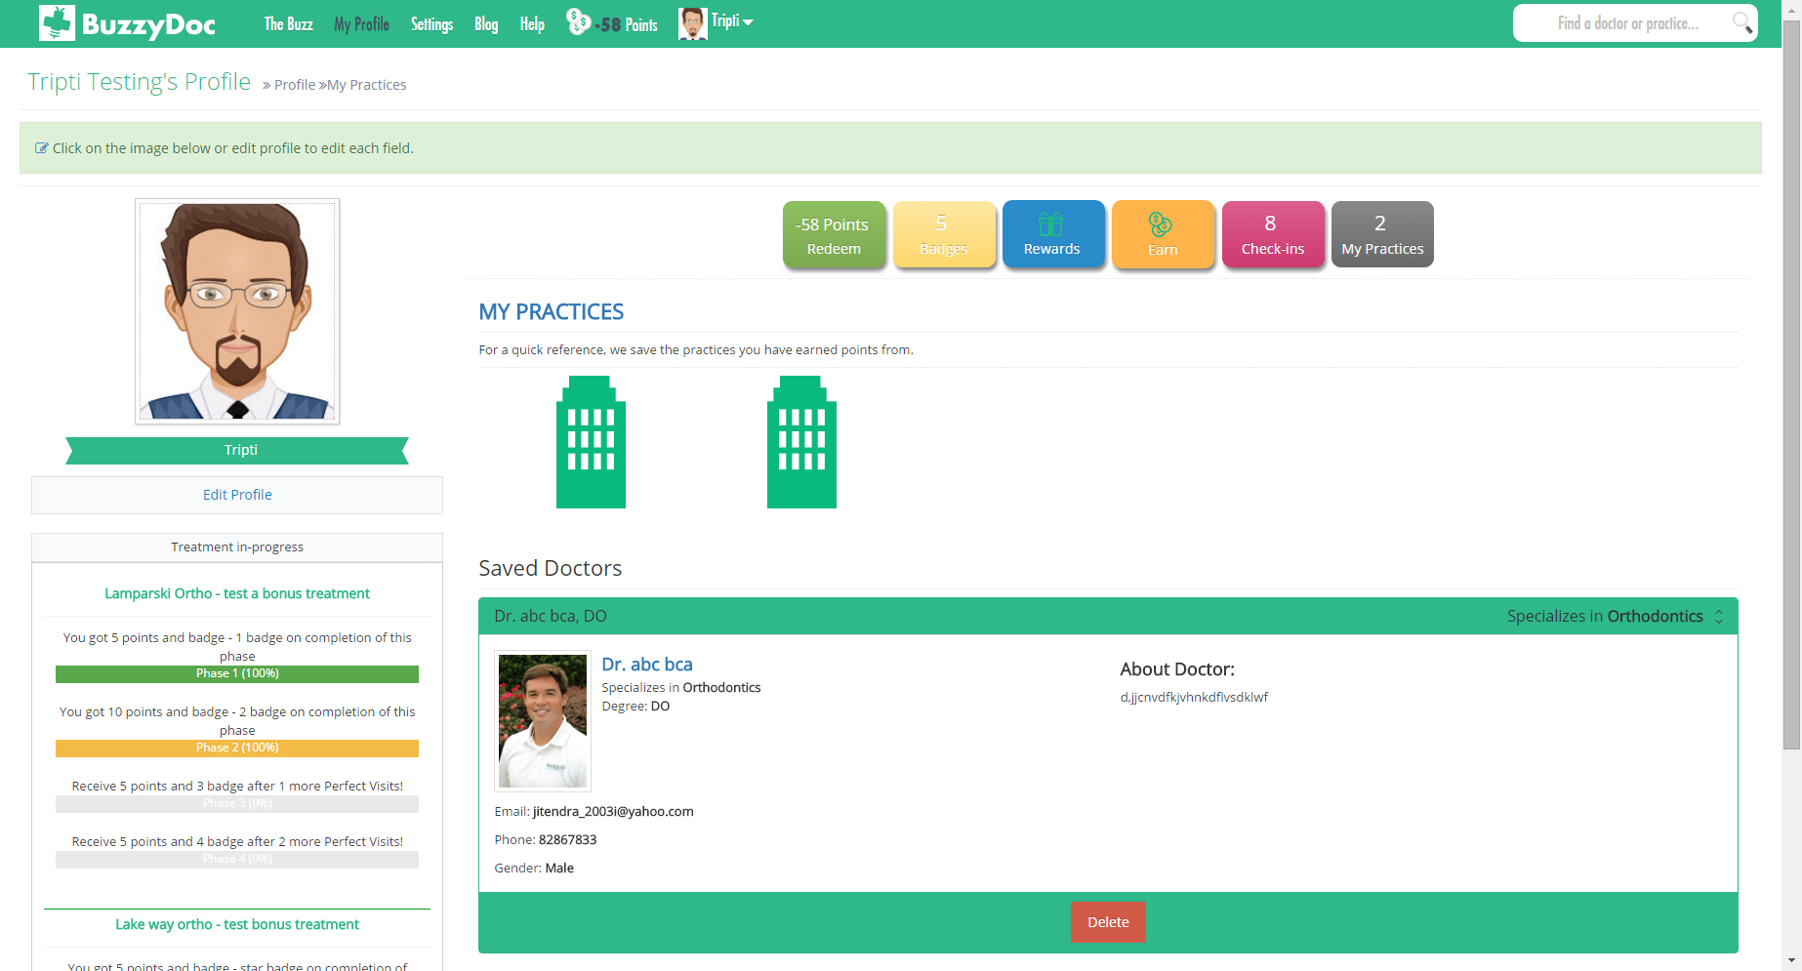

* **Edit Profile**

User can Edit profile by clicking Edit Profile button below Profile image.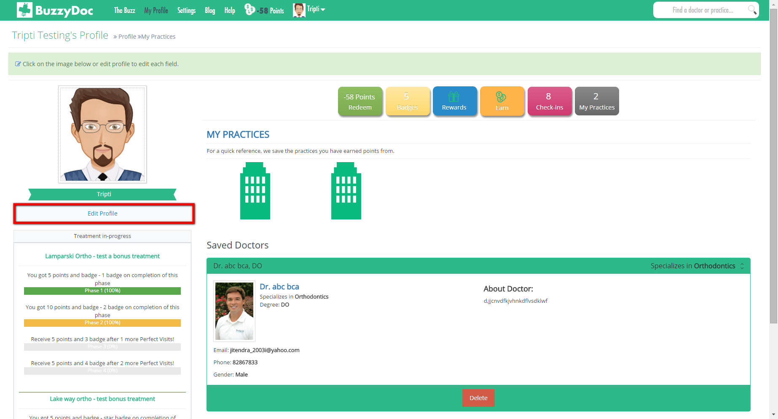

Once a user clicks on Edit profile button a form will show up on right side where User can update his/her profile.

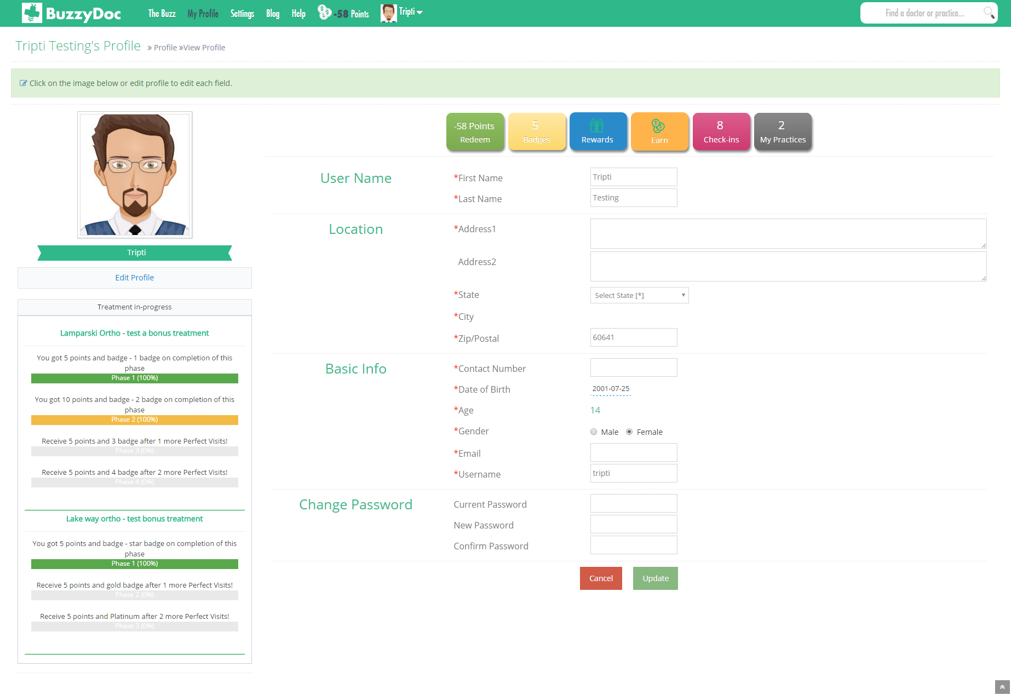

User is allowed to upload profile picture by clicking on image through different medium i.e. Facebook, PC or from Basket.

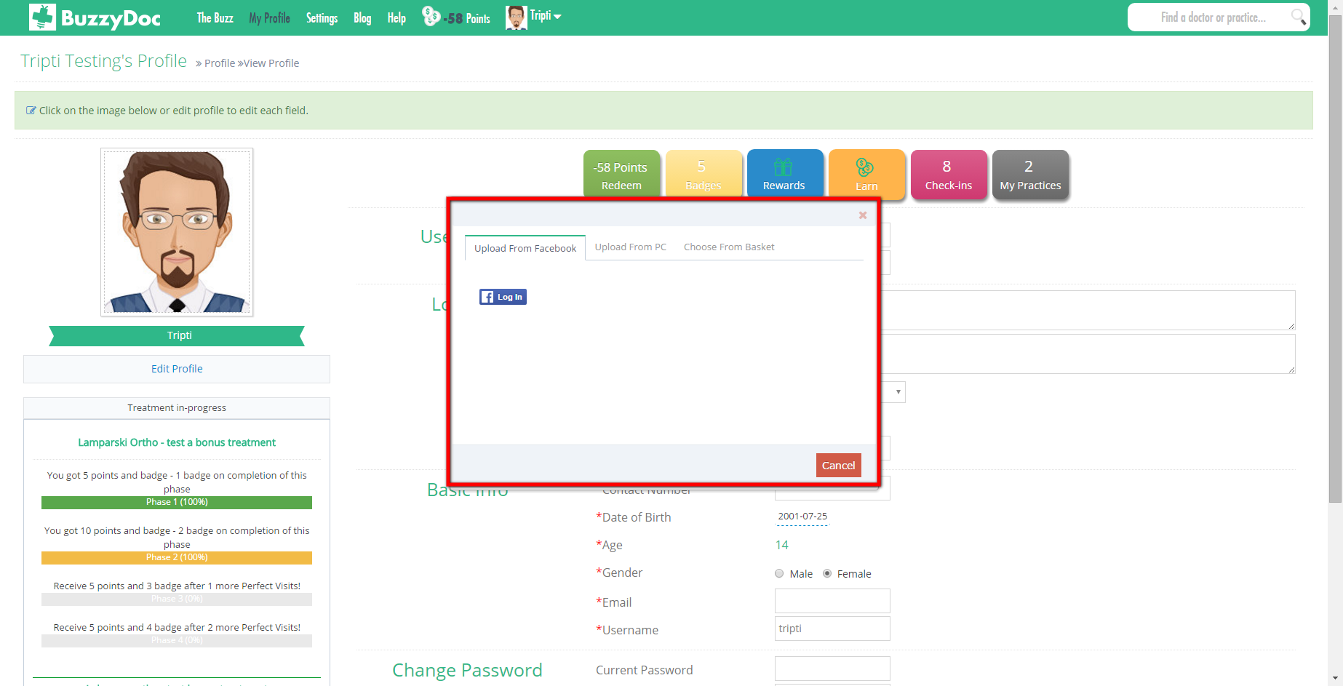

**4. Search Doctor or Practice**

**4.1 Search Doctor**

User can Search for Doctor by entering Name of the Doctor in Search bar

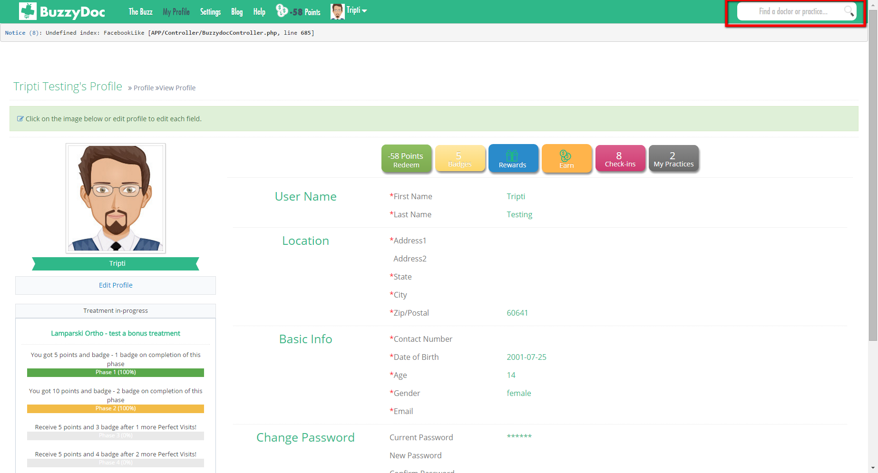

Once User Enters Name of Doctor Page gets redirected to Search Result where User can see all the matched result.

User can View Doctor’s profile by clicking View Full Profile button which leads to redirect the page to Doctors Profile Page.

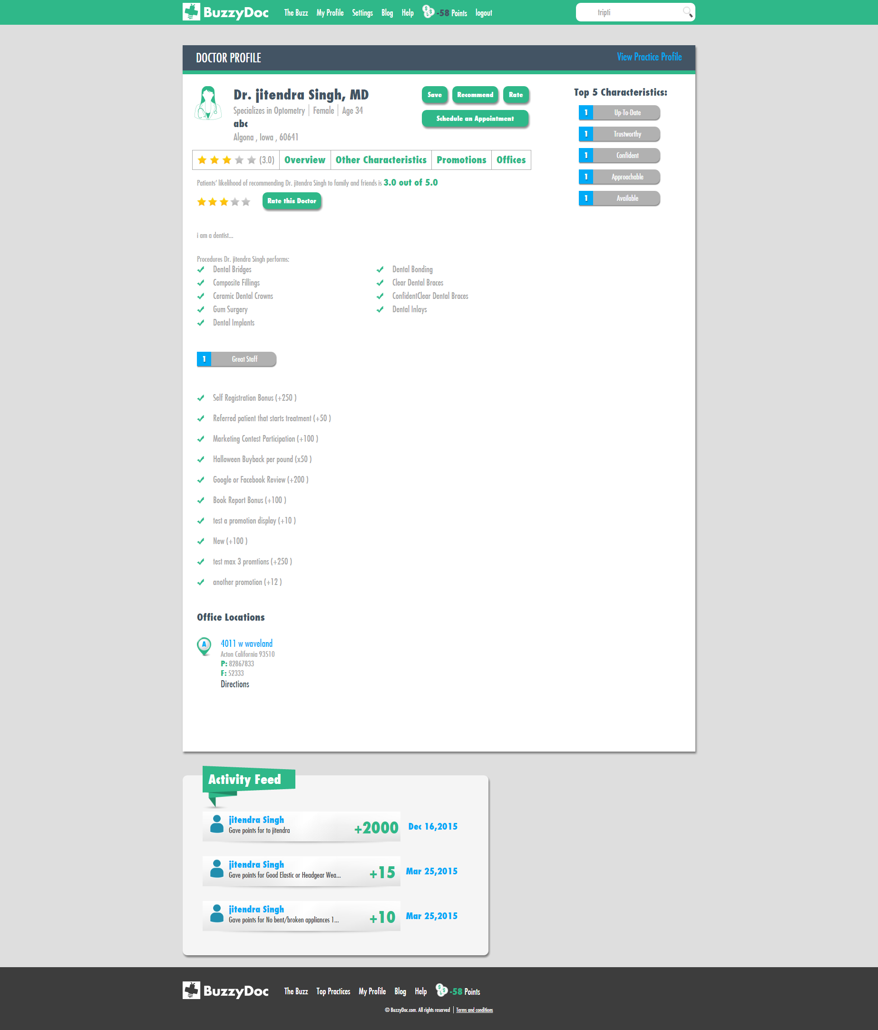

* On clicking Save button Doctors profile will be saved which will be shown on User Profile page under practice Tab
* User can Earn Points by clicking on Recommend button,where if Recommended user becomes patient of Doctor then User Earns Recommend points.
* User can Rate the Practice between 0 to 5 by clicking on Rate button
* By Clicking Schedule an Appointment button user is allowed to make appointment.

**Overview**

* It allows to give an Overview of the Doctor which describes all the Procedures, Insurance, Characteristic of Doctor

**Promotions**

* It describes all the Promotions supported by the Doctor

**Offices**

* All the locations of Doctor where he/she practice are shown under this tab.

**Activity Feed**

* Each Time Doctor Rewards points to Patients,points are recorded under Activity Feed

**4.2 Search Practice**

* User can Search Practices where they can Schedule an appointment, Rate and know more about the Practice by entering Practice name under Search Bar which redirects to all matched results

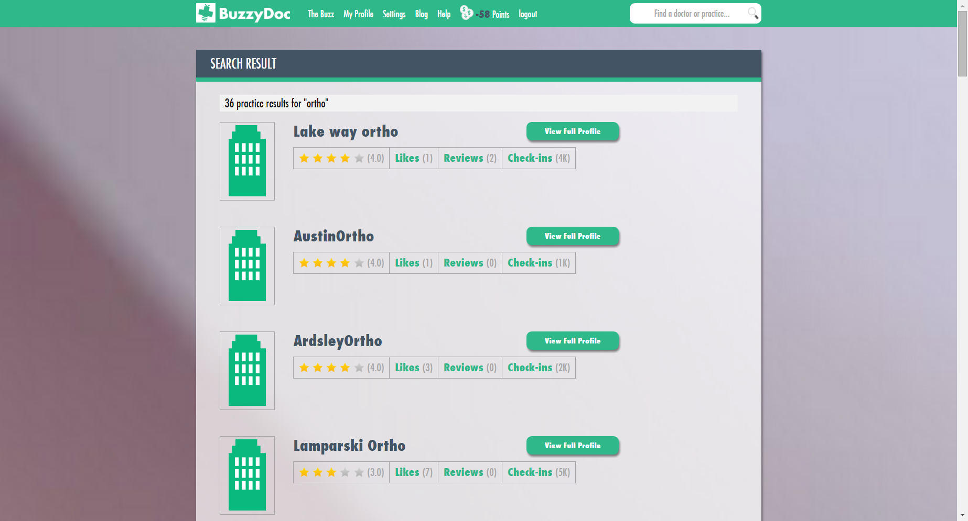

On clicking View Full Profile button user will be able to View all the details of the Practice

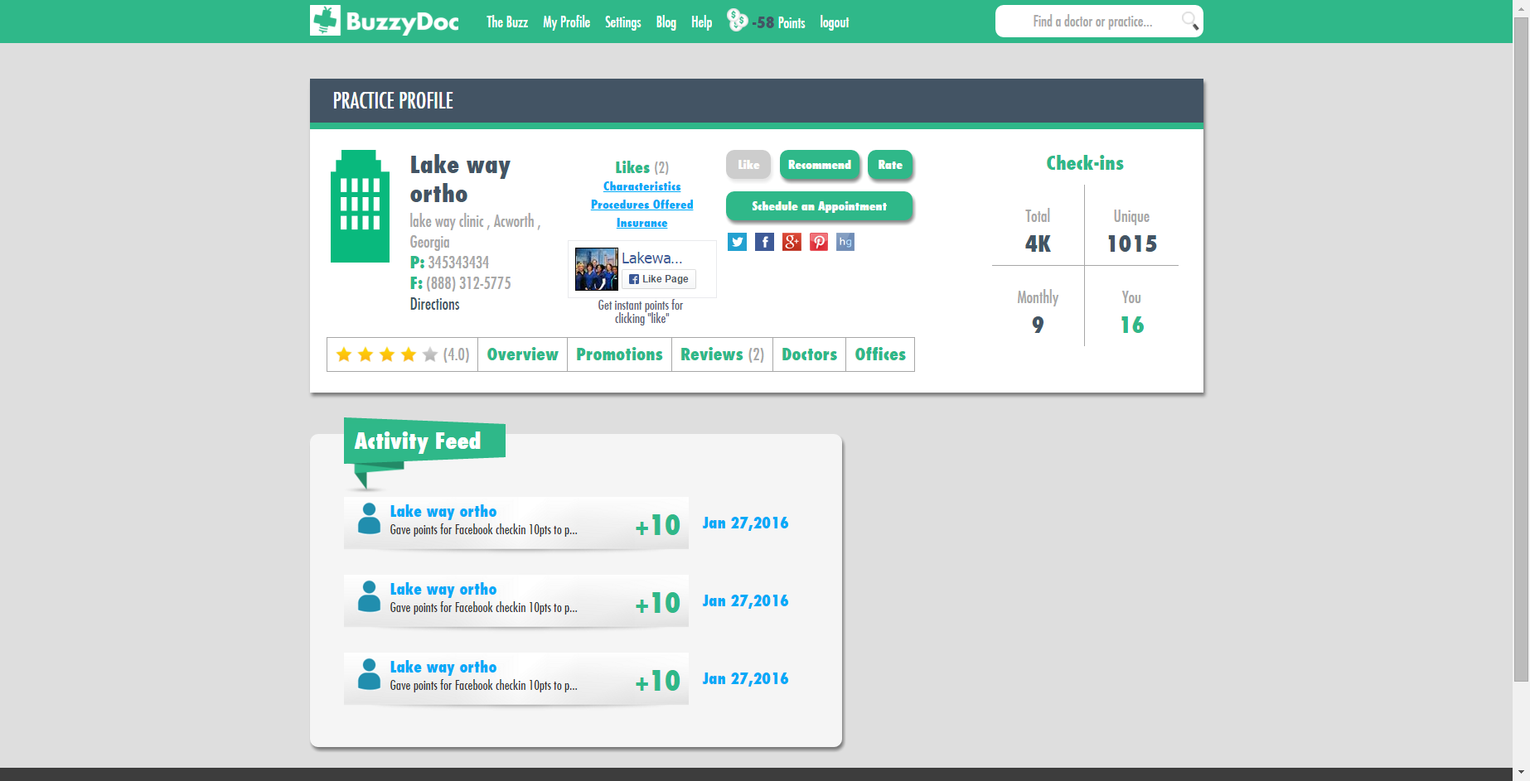

* Like Button allows to Save the practice
* User can Earn Points by clicking on Recommend button,where if Recommended user becomes patient of Clinic then User Earns Recommend points.
* User can Rate the Practice between 0 to 5 by clicking on Rate button
* By Clicking Schedule an Appointment button user is allowed to make appointment.
* Once User Likes Practice Facebook page User Earn points
* Like and Rate activity can be done only once for particular Practice

**Overview**

* It allows to give an Overview of the clinic which describes all the Procedures, Insurance, Characteristic of the clinic.

**Promotions**

* It describes all the Promotions supported by the Clinic

**Reviews**

* All Reviews given by the Doctors are shown under Reviews section

**Doctors**

* All the Doctors associated with the Practice are shown under this Tab. User can View Doctors profile by clicking View Full Profile button under Doctor's name.

**Offices**

* All the locations of Practice are shown under this tab.

**Activity Feed**

* Each time Staff member gives points to User it is recorded under Recent Feed

**5. The Buzz**

* All the activities done under the client by any Practice or by User is shown under The Buzz.

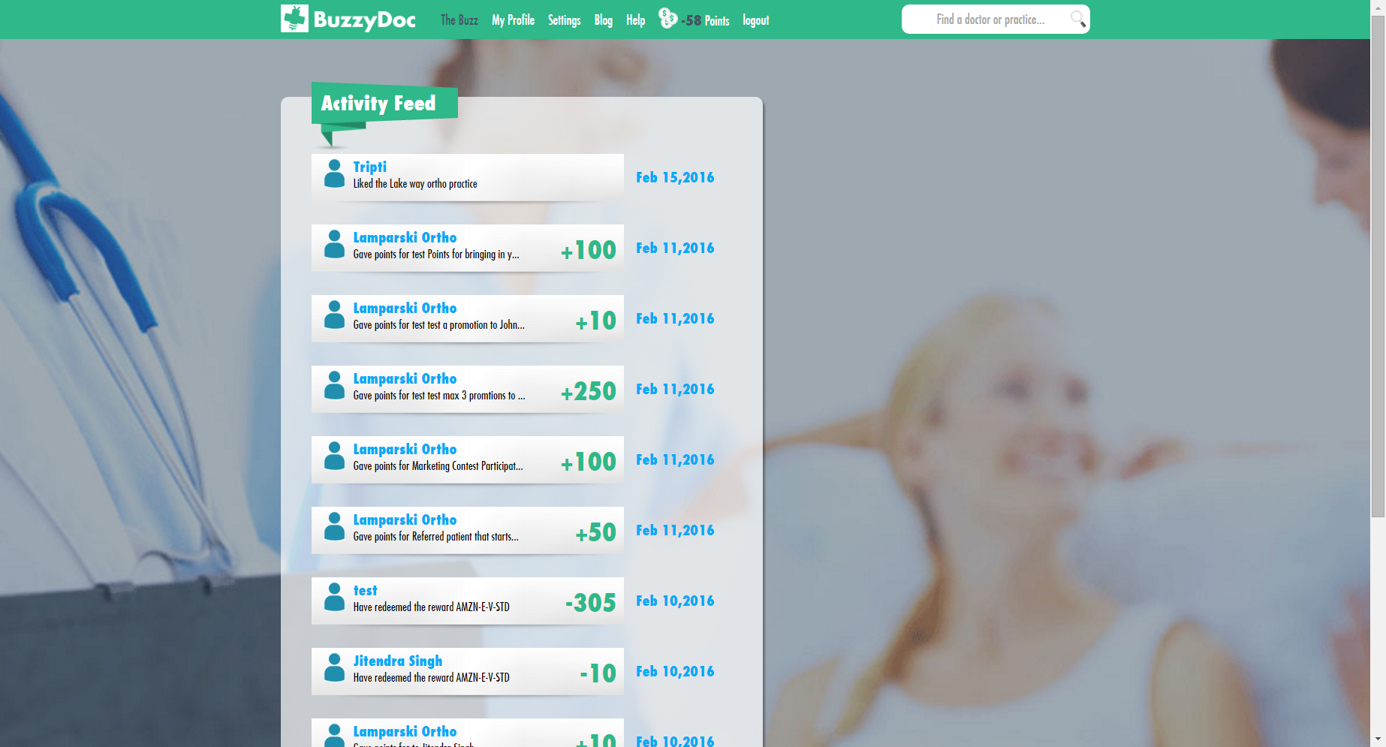

**6. Settings**

* User can turn on/off the notifications related to Rewards,Order and Points
* User can view status of Recommended patients and can Invite other people also
* User can View Documentation of the clinic

